**UNIVERSITY OF DAR ES SALAAM**

**COLLEGE OF INFORMATION AND COMMUNICTION TECHNOLOGIES**

**DEPARTMENT OF COMPUTER SCIENCE AND ENGINEERING**



**PROJECT REPORT: IS 335**

**PROJECT TITLE: GARBAGE COLLECTION**

**Student Name:** Ibrahim G Ibrahim

**Reg. No:** 2018-04-02417

**Name of Supervisor:** Dr. Wilbard Nyamwihula

**Supervisor`s Signature: ……………………….**

**Date: ……………………….**

# **Declaration**

I declare that this report and the work described in it are my own work, with any contributions from others expressly cited/acknowledged. I declare that the work in this report was carried out in accordance with the Regulations of the UDSM and has not been presented to any other University for examination either in Tanzania or overseas.

Ibrahim G Ibrahim

Signature: …………………

Date: …………………

# **Abstract**

This report concerned with the development of garbage collection management system. It composed in terms of chapters. It generally describes different concepts like Project statements problem, objectives, significance, literature review, methodology, system analysis and design, system implementation, recommendations and conclusion have addressed too.

Garbage collection management system will allow householders themselves to request pick for garbage collection when there is a need, provide daily collecting schedule and allow user to provide views and feedbacks.

To develop garbage collection management system, iterative development approach used in order to improve development speed. The tools in requirement elicitation to be used are meetings, interviews, e-mails, and existing documents study and garbage collecting process observation.

Significances of this project includes the following: To provide the information on daily schedule online, to encourages environmental cleanness and to minimize road encroachment problems.

Some of project constraints, Project control budget, control work plan, conclusions and recommendations as well as references are included.

Generally, garbage collection management systems are very important in today’s urban environment due to the development of urbanization, so it is my hope that, this report will be useful for further development and research findings concerning garbage collection management systems.

# **Acknowledgements**

I would like to thank the almighty GOD and my parents, who have always guided me to walk on the right path in life. I acknowledge, with a deep sense of gratitude and most sincere appreciation, the valuable guidance and unfailing encouragement.

This report has made due to the efforts and encouragement provided by variety of people, many individuals contributed their time, expertise and advice to the writing of this report among of them are Seth Goodluck and Baruti Baruani.

Special thanks to supervisor, Dr. Wilbard Nyamwihula and members of COICT for their contributions and guidelines during whole period in the college and writing of this report.

My heartfelt gratitude and indebtedness go to all those people in my life who gave me constructive criticism, as it contributed directly or indirectly in a significant way towards the completion of my work much appreciation to you all.

God bless you all.

Contents

Declaration i

Abstract ii

Acknowledgements iii

List of Abbreviations v

List of Figures vi

1.0 Chapter One: Introduction to Garbage Collection 1

1.1 Statements of the Problem 1

1.2 Project Objectives 2

1.2.1 Main Objective 2

1.2.2 Specific Objectives 2

1.3 Significance of the Project 2

1.4 Scope and limitation 2

1.5 Organization of the report 2

2.0 Chapter Two: Literature Review 4

3.0 Chapter Three: Project Methodology 6

3.1 Development Approach 6

3.2 Requirement gathering techniques 7

3.3 Tools and methods used 7

4.0 Chapter Four: System Analysis and Design 9

4.1 Requirement gathering 9

4.2 Requirements analysis 10

4.3 Requirements specification 14

References 16

Appendices 17

|  |  |
| --- | --- |
| **List of Abbreviations** |  |
|  |  |
| CoICT  FYP  IT  SDLC  UDSM | College of Information and Communication Technology  Final Year Project  Information Technology  System Development Life Cycle  University of Dar es Salaam |

# **List of Figures**

Figure 1: Iterative development 6

Figure 2: Actor user and its use case 10

Figure 3: Actor system admin and its use case 10

Figure 5: ERD of the system 14

# **Chapter One: Introduction to Garbage Collection**

## 1.1 Statements of the Problem

In our country, management of garbage materials is performed poorly, resulted to variety of problems that affect environment including:

Air pollution; through decay or burning of garbage materials. Open burning of garbage is commonly seen within the city and these generate serious greenhouse gases and other hazardous gases that pollute the air. The dump sites are randomly scattered in some open spaces very close to residential homes and public buildings, in most cases garbage dump bins are not covered.

Road encroachment; Roads should be clear of any obstructing materials for increased access and visibility in order to reduce the risks of accidents or other physical harm to the road users. However, the scenario is different, garbage do encroach the roads even in the major streets with the consequence that a very narrow part is left for pedestrians and motorists to use. As for now, absent of clear information to garbage collection has resulted to problems. Hence there is a need of a system to facilitates the collecting of garbage from household to the dumping area to encourage making the environment clean and providing online information for collection schedule.

**Existing system**

Manual based where picking of garbage is done once after two to three weeks in which they announce physically to the street for people to bring their garbage.

**Problem Statement**

Absent of online schedule and information to garbage collection:

Some of people might not be available during announcement for removing garbage from their place, hence fails to collect that specific day result to environment dirtiness and bad smells to the society. Also, some people with hearing problem could be difficult for them to know.

**Proposed system**

Garbage collection management system to facilitate the collecting and dumping of garbage materials from householders by allowing themselves request to pick garbage once there is a need and to provide online schedule and information to garbage collection.

## Project Objectives

The objectives of this project have been grouped into two, main objective and specific objectives.

### Main Objective

a. To develop garbage collection management system to facilitate the collecting and dumping of garbage materials.

### 1.2.2 Specific Objectives

1. To establish requirements for garbage collection management system;
2. To design the garbage collection management system based on requirements established in (a);
3. To develop the garbage collection management system based on design in (b).

## 1.3 Significance of the Project

The significance of this project are as follows:

1. To provide the information on daily schedule online. Hence facilitate the collecting of garbage on time when needed.
2. To encourages environmental cleanness. By ensuring garbage are collected quickly when request made and garbage dump bins are covered to avoid bad smells (air pollution).
3. To minimize road encroachment problems. Roads will be clear of any obstructing materials for increased access and visibility to reduce the risks of accidents to the road users.

## 1.4 Scope and limitation

It is a mobile based application to facilitate the collecting and dumping of garbage materials.

It will allow users to request a pick of garbage collection on demand, view collection schedule and report a problem or providing the feedbacks example missed collection for further improvement.

The system will not work without power and when no maintenance at the required time.

## 1.5 Organization of the report

This report is organized into six chapters.

Chapter one is introduction to garbage collection. It describes different concepts including statements of problem, project objectives and Project significances.

Chapter two is the literature review. Developments of garbage collection systems and the existing systems have summarized. Including observation to Taka cycle and Yo-Waste mobile Application.

Chapter three is project methodology. In which the approach, tools and methods to be used have addressed example project will be implemented through Rapid application development using iterative development approach, use of interviews, observation and reading available document will be used to gather and capture the requirements.

Chapter four is System analysis and design. It describes requirement gathering and capturing, requirement analysis and requirement specification as well as database design

Chapter five is System implementation.

Chapter six is conclusions and recommendations

Finally, it is my hope that, this report will be useful reference for further research findings and development of garbage collection management systems.

**Project work plan**

|  |  |  |  |
| --- | --- | --- | --- |
| S/N | Objective | Deliverable | Duration |
| a | To establish requirements for garbage collection management system; | Requirement definition | 17/12/2020 to 16/1/2021 |
| b | To design the garbage collection management system based on requirements established in (a); | System specification | 18/1/2021to 14/2/2021 |
| c | To develop the garbage collection management system based on design in (b). | New system (Garbage Collection) | 1/4/2021 to 21/4/2021 |

**Budget**

Initial estimations of the project costs:

|  |  |  |
| --- | --- | --- |
| S/N | Description | Estimated cost |
| 1 | Internet bundle budget | 20,000 |
| 2 | Transport cost budget | 15,000 |
| 3 | Printing reports | 15,000 |
| 4 | Emergency and others | 10,000 |
|  | Total (TSH) | 60,000 |

# **2.0 Chapter Two: Literature Review**

The existing projects and developed applications have summarized as follows: -

Taka Cycle: a mobile application, developed by RIG Inc in Tanzania and was released since 2nd, October 2019. The application has different features like Request Waste Pickup on Demand, to select location for your own service, schedule, recycling news and up to date environmental news.

Yo-Waste, a mobile application developed by Yo-Waste LL. Location-based on-demand garbage collection services for businesses and households. The application is currently operating in Uganda and was released on 29th, May 2019. It has different features like OnDemand Pickup, Special Pickup, to specify the collection, select collection type, requests and confirm request and to view schedules.

(Arebey, et al. 2010), presented the design model of a waste collection system which used RFID (Radio Frequency Identification), a GPS (Global Positioning System) and cameras. The system also used Digital Image Processing to determine how full the containers were.

(Chen, 2010), analyzed the spatial inequality in municipal solid waste disposal across regions in the developing countries and developed a multiple regression model to quantify the relationship between several factors (such as population density, old age composition, unemployment rate, the education level) and municipal solid waste disposed (as the dependent variable).

(Johansson, 2006) In Sweden, presented his optimization study for a solid waste collection process using a container system equipped with 3300 sensors and wireless communication equipment. In order to decide the optimal route in the waste collection process, real-time data obtained from the containers were used. At the end of the study, it was determined that the cost of collecting solid waste had been reduced by 10 to 20 %.

(Vicentini, et al., 2009) The study carried out illustrates the structure of a waste collection system which uses containers installed with waste-level detection sensors.

Based on this project, Garbage collection management system aims to facilitates the collecting of garbage from householders by allowing themselves to request to pick garbage when there is a need, to the dumping area, this will encourage making the environment clean, also, to provide daily garbage collection schedule and allow users to give their feedback (views or report a problem).

# **3.0 Chapter Three: Project Methodology**

Introduction

A methodology, is a formalized approach to implementing the SDLC (list of steps and deliverables). There are many different systems development methodologies, and they vary in terms of the progress followed through the phases of the SDLC.

## 3.1 Development Approach

In this project, Rapid application development (RAD) using iterative development approach is proposed for use. Because, RAD improve the speed and quality of systems development. Iterative development breaks the overall project into a series of versions that are developed sequentially.

The most important and fundamental requirements are bundled into the first version of the system. This version is developed quickly and once implemented; the users can provide valuable feedback to be incorporated into the next version of the system.

(Dennis, Haley & Roth, 2012).

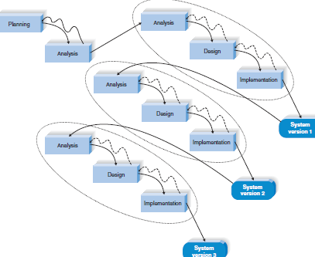

Figure 1: Iterative development

## 3.2 Requirement gathering techniques

Requirement elicitation techniques

Collecting requirements of the system from the stakeholders (householders) will involves the following techniques:

1. Interview

Most commonly used requirements elicitation technique.

It is natural.

One on one or Group interview.

Steps to be involved are:

* Selecting interviewees
* Designing interview questions (Open-ended questions will be used for elaboration of the interviewee)
* Preparing for the interview
* Conducting the interview
* Interview report

1. Observation

* Observation, watching processes being performed,
* To check validity of information.

1. Document analysis

Reading existing documentations prepared by other people concerning the problems. also, literature review is a very important method, more knowledge about the problem and its solution I have acquired, that helped to design the garbage collection system successfully, by understanding previous projects so as to develop a more effective solution to the problem. This helped me to collect data and expanding ideas about the problem.

## 3.3 Tools and methods used

* Use cases

A use case, describes the sequence of events of some types of users called actors, using some part of the system functionality to complete a process.

It describes what the system does to accomplish a particular user’s goal.

Therefore, it is a description of a set of interactions between a user and the system.

* Brainstorming

Brainstorming technique helped me to formulate and get ideas as well as to identify all possible solution to the problem.

# **4.0 Chapter Four: System Analysis and Design**

SYSTEM ANALYSIS

Involves Requirement Capture and Analysis where the system’s services, constraints and goals are established by consultation with system users.

They are then defined in detail and serve as a system specification

## 4.1 Requirement gathering

• Requirement Gathering/Elicitation (capturing)

* Requirement gathering is a communication process between the parties involved and affected in the problem situation.
* The tools in elicitation are meetings, interviews, e-mails, and existing documents study and facts findings and process observation technique.
* The sources are: Customer End Users, Stakeholders

Core/Basic Activities for the Garbage Collection Management System

* Management of system users (System admin and customer)
* Management of garbage collection processes
* Management of garbage collection points (centers)
* Management of user feedbacks

Activities for each Core Activities

1. Management of System users

* Registering system users to the system
* Assign login credentials to the users

1. Management of garbage collection processes

* Create a form for making a request for garbage to be collected
* Create time schedule and location
* Control time to request a garbage collection pickup
* Link request form and a user
* Admin to view garbage collection requests made

1. Management of garbage collection points

* Create a collection point
* Customer to select a collecting point or
* Link a collection point and the customer

1. Management of feedbacks

* Create a form for users to report a problem
* Display for admin to view feedback

# 4.2 Requirements analysis

Use case and Description

Use case

A use case, describes the sequence of events of some types of users, called actors, using some part of the system functionality to complete a process.

It describes what the system does to accomplish a particular user’s goal.

Therefore, it is a description of a set of interactions between a user and the system.

An actor, is someone who can initiate a use case.

In this project, the actors involved are customer and System admin.

|  |  |
| --- | --- |
| Actor | Description |
| Customer | An actor responsible in preparing the garbage to be collected (usually a householder who request a garbage collection pickup) |
| Admin | An actor who will manage the whole system including management of users and management of garbage collection process |

Use Cases of Garbage collection management system

* Management of users (Customers and admin)
* Management of garbage collection processes
* Management of feedbacks
* Management of collection points(centers)

Use case Diagram:

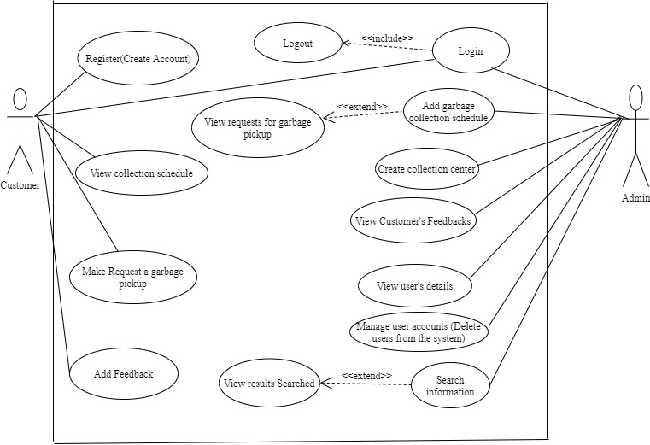

Figure 2: Use Case Diagram

Use Case Description.

* Management of the system users

|  |  |
| --- | --- |
| Use case: | Management of the system users |
| Actors: | Customer |
| Description: | This is where users (customers) are registered |
| Pre-condition: |  |
| Post-condition: | Any change made have to be updated |
| Main flow: | 1. System display a page to manage users and requests 2. System admin checks different information and their validity 3. System admin takes appropriate action 4. Update and save changes made |
| Exception flow(s) | If the user provides wrong information |

* Management of garbage collection process

|  |  |
| --- | --- |
| Use case: | Management of garbage collection process |
| Actors: | System user and admin |
| Description: | This is where user make a request for the garbage to be collected. |
| Pre-condition | The user must be registered into the system and logged in. |
| Post-condition | Request made should be recorded in the database |
| Main flow | 1. System display make a request page 2. User make a request 3. System acknowledge after making a request |
| Exception flow | If the submitted request is not complete, the system should display an error and make a user recorrect |

* Management of User feedbacks

|  |  |
| --- | --- |
| Use case: | Management of User feedbacks |
| Actors: | System user |
| Description: | Allows user to provide feedbacks (report a problem, views and suggestion) |
| Pre-condition | The user must be registered into the system and logged in. |
| Post-condition | Feedback should be sent to System admin |
| Main flow | 1. System to display a feedback page  2. User to write feedbacks (opinion)  3. To submit the feedback |
| Exception flow | If the submitted opinion is irrelevant, no further action would be taken |

* Management of collection points

## 4.3 Requirements specification

(a) Functional requirements

Functional requirements of the system are those that relate directly to the functioning of

the system. It includes the following:

|  |  |  |
| --- | --- | --- |
| Ref No | Functional Description | Category |
| F1 | MANAGEMENT OF SYSTEM USERS. |  |
| F1.1 | The system should allow customer to make registration (register) | Evident |
| F1.2 | The system should allow registered user to login | Evident |
| F1.3 | The system should allow admin to view users’ details | Evident |
| F2 | MANAGEMENT OF GARBAGE COLLECTION PROCESS. |  |
| F2.1 | The system should allow admin to upload collection schedule | Evident |
| F2.2 | The system should allow users to make request for garbage collection |  |
| F3 | MANAGEMENT OF FEEDBACKS. |  |
| F3.1 | The system should allow users to provide feedback and suggestion | Evident |
| F3.2 | The system should allow admin to view feedbacks (reported problems) | Evident |
| F4 | SEARCHING FUNCTION |  |
| F4.1 | The system should allow admin to search and view information | Evident |
| F5 | MANAGEMENT OF COLLECTION POINTS (CENTERS) |  |
| F5.1 | The system should allow admin to create a collection center |  |
| F5.2 | The system should allow customer to view and optional choose collection point |  |

(b) Non-functional requirements

Non-functional requirements of the system; are constraints/restrictions imposed on the system. It includes:

|  |  |
| --- | --- |
| Attribute | Constraints |
| Device compatibility | The system should run on android mobile phone |
| Reliability | The system should be available for use 24 hours per day |
| Security | The system should protect user accounts |

SYSTEM DESIGN

1. Database Design

The Entity-Relationship Diagram

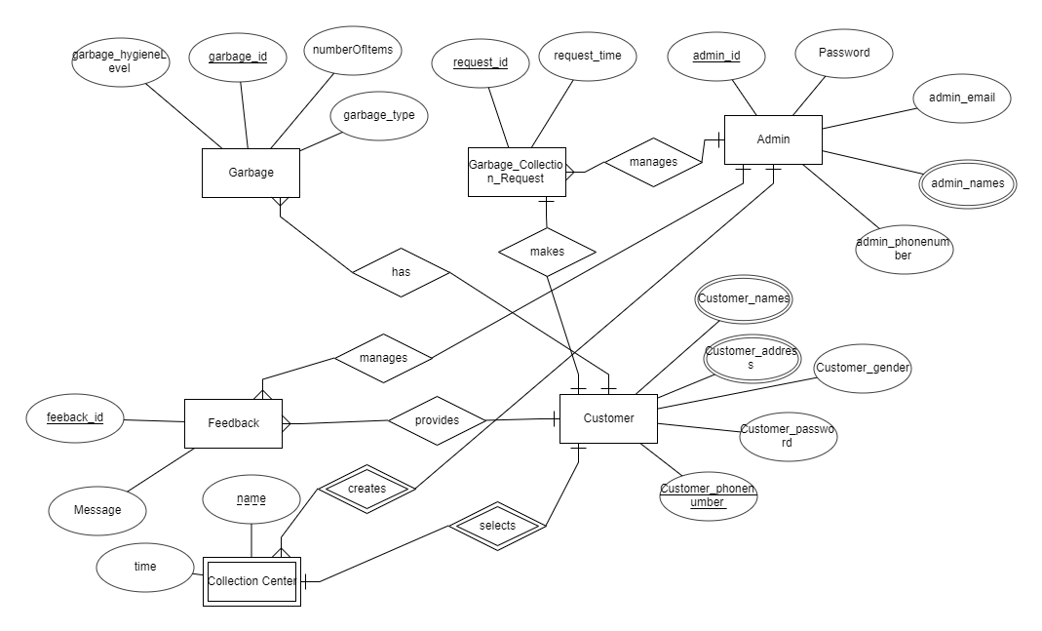

Figure 4: Entity Relationship Diagram

# **References**

Arebey, M., Hannan, M.A., et. al. (2010). RFID and integrated technologies for solid

waste bin monitoring systems. In: *Proceedings of the world congress on engineering 2010,* vol I, WCE 2010, June 30–July 2, London, UK.

Chen, C.C. (2010). Spatial inequality in municipal solid waste disposal across regions

in developing countries. *Int J Environ Sci Technol* 7(3):447–456.

Dennis, A., Haley, B. W., & Roth, R. M. (2012). *Systems analysis and design*

(5th edition). John Wiley & Sons, Inc. USA.

Huisman, O., & de By, R.A. (2009). *Principles of Geographic Information Systems*

(4th edition). ITC Educational Textbook Series. The Netherlands.

Johansson, O.M. (2006). The effect of dynamic scheduling and routing in a solid

waste management system. *Waste Management* 26:875–885.

Sommerville, I. (2011). *Software engineering* (9th edition). Pearson Education, Inc. USA.

Vicentini, F., Giusti, A., et. al. (2009). Sensorized waste collection container for content

estimation and collection optimization. *Waste Management* 29:1467–1472.

# 

# **Appendices**

Tasks and Time schedule

